
IV Curve Plotting
Lab Manual for HND EEE & Mechatronics Semester 1
Akbar Qamar | 11/3/25 | [Course title]

Contents
1. IV Curves for Short and Open 7
Objective: 7
Theory: 7
Materials Required: 7
Safety Precautions: 7
Pre-Experiment Setup: 8
Procedure: 8
Measurement Data Table (Simulation): 9
IV Curve Plot (Simulation): 9
Measurement Data Table (Hardware): 10
IV Curve Plot (Hardware): 10
Lab Evidence(s) of Hardware Testing: 10
Measurement Data Table (Simulation): 12
IV Curve Plot (Simulation): 13
Measurement Data Table (Hardware): 13
IV Curve Plot (Hardware): 14
Lab Evidence(s) of Hardware Testing: 14
2. IV Curve for a Silicon Diode 15
Objective: 15
Diagram: 15
Theory: 15
Expected IV Curve: 16
Materials Required: 16
Safety Precautions: 16
Pre-Test Setup: 16
Procedure: 17
Measurement Data Table (Simulation): 17
IV Curve Plot (Simulation): 18
Measurement Data Table (Hardware): 18
IV Curve Plot (Hardware): 19
Lab Evidence(s) of Hardware Testing: 19
Plotting the IV Curve: 19
Observations and Analysis: 20
Hints: 20
Troubleshooting: 20
3. IV Curve for a Zener Diode 21
Objective: 21
Diagram: 21
Theory: 21
Expected IV Curve: 22
Materials Required: 22
Safety Precautions: 22
Pre-Test Setup: 22
3. Measurement: 22
Procedure: 22
Lab Evidence(s) of Hardware Testing: 25
Plotting the IV Curve: 25
Observations and Analysis: 26
Hints: 26
Troubleshooting: 26
4. IV Curve for a Fixed Value Resistor (100 Ω) 27
Objective: 27
Diagram: 27
Theory: 27
Materials Required: 27
Safety Precautions: 28
Pre-Test Setup: 28
Connect the resistor in series with the power supply. 28
Multimeter in series for current, parallel for voltage. 28
If using oscilloscope XY mode, connect as per scope instructions. 28
Procedure: 28
Lab Evidence(s) of Hardware Testing: 30
Plotting the IV Curve: 30
Observations and Analysis: 31

Hints: 31
Troubleshooting: 31
5. IV Curve for a Light Dependent Resistor (10kΩ LDR) 32
Objective: 32
Diagram: 32
Theory: 32
Materials Required: 32
Safety Precautions: 33
Pre-Test Setup: 33
Connect LDR in series with power supply. 33
Multimeter for current and voltage. 33
Oscilloscope in XY mode for live curve. 33
Prepare light source for varying illumination. 33
Procedure: 33
Measurement Data Table (Simulation): 33
IV Curve Plot (Simulation): 34
Measurement Data Table (Hardware): 34
IV Curve Plot (Hardware): 35
Lab Evidence(s) of Hardware Testing: 35
Plotting the IV Curve: 35
Observations and Analysis: 36
Hints: 36
Troubleshooting: 36
6. IV Curve for a Potentiometer (5kΩ) 37
Diagram: 37
Theory: 37
Materials Required: 37
Safety Precautions: 38
Pre-Test Setup: 38
Connect potentiometer in series with power supply. 38
Multimeter for current and voltage. 38
Oscilloscope in XY mode for live curve. 38
Procedure: 38
Measurement Data Table (Simulation): 38
IV Curve Plot (Simulation): 39
Measurement Data Table (Hardware): 39
IV Curve Plot (Hardware): 40
Lab Evidence(s) of Hardware Testing: 40
Plotting the IV Curve: 40
Observations and Analysis: 41
Hints: 41
Troubleshooting: 41

IV Curves for Short and Open

Objective:
- To measure and plot the current-voltage (IV) characteristics of three basic elements: a short (wire), an open circuit, and a resistor.
- To understand how to interpret IV curves and recognize linear and nonlinear behaviours in electronic components.

Theory:
- Short Circuit (Wire):
  - A short circuit has nearly zero resistance, so the voltage across it remains close to zero regardless of the current. The IV curve for a short circuit is nearly a vertical line near $V=0$.
- Open Circuit:
  - An open circuit has infinite resistance, meaning no current flows regardless of the applied voltage. The IV curve for an open circuit is a horizontal line near $I=0$.
- Resistor:
  - A resistor is a linear device that obeys Ohm's Law: $V=IR$. Its IV curve is a straight line with slope equal to the resistance $R$.
By plotting these IV curves, students will learn the fundamental IV characteristics and identify the distinct behaviours of these basic devices.

Materials Required:
- Short Circuit: A simple wire.
- Open Circuit: An open connection (no device installed).
- Resistor: A known resistor, e.g., 100 Ω, 1 W.
- Digital Power Supply: Preferably with fine current and voltage control, capable of measuring both current and voltage accurately.
- Optional: External Digital Multimeter for voltage and/or current measurement (can be omitted if the power supply has sufficient resolution for direct measurements).

Safety Precautions:
- Maximum Current: Set a maximum current limit of 100 mA to prevent overheating of the resistor or other connections.
- Reset Supply to Zero: Always set the voltage/current of the power supply to zero before connecting or switching devices under test.
- Step Changes Gradually: In cases of insignificant voltage changes, current steps can be made larger but avoid abrupt large changes.

Pre-Experiment Setup:
- Prepare the Circuit:
  - For each test (short, open, resistor), connect the device under test (DUT) in series with the power supply.
  - If using an external multimeter, connect it:
    - In series with the DUT for current measurements.
    - In parallel across the DUT for voltage measurements.
- Measurement Steps:
  - Gradually increase the current or voltage depending on the device under test.
  - Take at least 10 readings for positive bias (current in one direction).
  - For open and short circuits, repeat 5–10 readings for negative bias (reverse current by swapping power supply terminals).
    - Resistors are unidirectional, but reverse testing can still be performed to verify symmetry.
  - Record measurements as indicated in the table below.

Procedure:
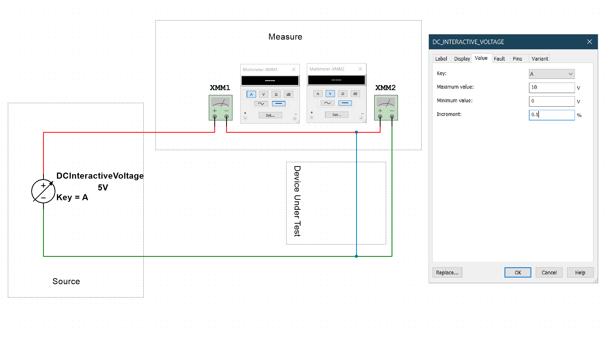
1. Short Circuit:
- Connect a piece of wire as the DUT.
- Gradually increase the current in small steps (e.g., 10, 20, 30 mA).
- Record the corresponding voltage across the wire for each current step. The voltage should remain nearly zero.
- For reverse measurements, reverse the current by swapping the power supply terminals and repeat the steps.

Measurement Data Table (Simulation):
Step No. | Current (mA) |  | Voltage (V) | Comments/External Factors

IV Curve Plot (Simulation):

Measurement Data Table (Hardware):
Step No. | Current (mA) |  | Voltage (V) | Comments/External Factors

IV Curve Plot (Hardware):

Lab Evidence(s) of Hardware Testing:

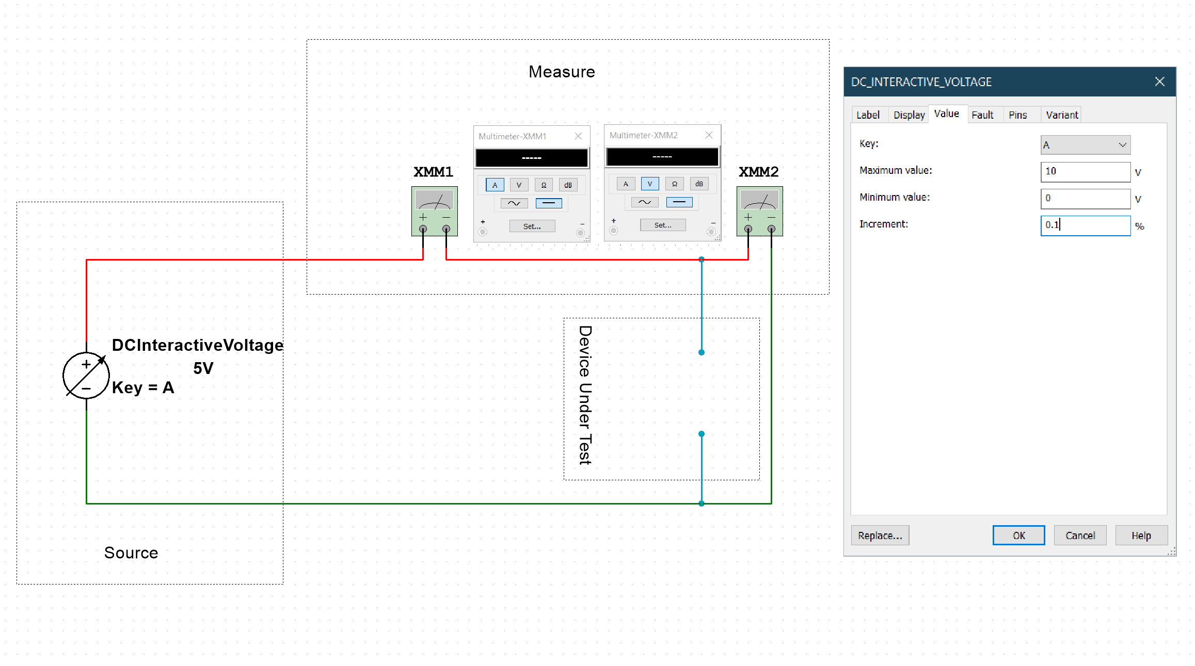
2. Open Circuit:
- Remove any device to simulate an open circuit.
- Gradually increase the voltage on the supply while observing the current. The current should remain close to zero.
- Record voltage and current at 10 evenly spaced steps of applied voltage in both forward and reverse bias.

Measurement Data Table (Simulation):
Step No. | Current (mA) |  | Voltage (V) | Comments/External Factors

IV Curve Plot (Simulation):

Measurement Data Table (Hardware):
Step No. | Current (mA) |  | Voltage (V) | Comments/External Factors

IV Curve Plot (Hardware):

Lab Evidence(s) of Hardware Testing:

2. IV Curve for a Silicon Diode

Objective:
- To measure and plot the current-voltage (IV) characteristics of a silicon diode.
- To study its nonlinear behaviour in forward and reverse bias regions, including the identification of its knee voltage and leakage current.

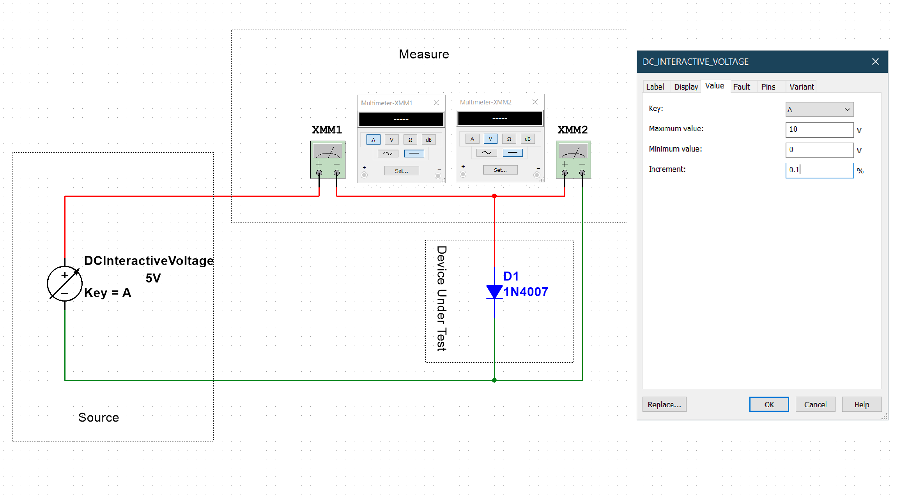
Diagram:

Theory:
A silicon diode is a semiconductor device that allows current flow primarily in one direction. Its IV curve exhibits the following traits:
- Forward Bias:
  - Forward biased when the positive terminal of the power supply is connected to the anode and the negative terminal to the cathode.
  - Initially, the current remains low until the voltage exceeds the knee voltage (~0.6–0.7V for Si diodes). Beyond this voltage, current rises exponentially.
- Reverse Bias:
  - Reverse-biased when the terminals are swapped (positive to cathode, negative to anode).
  - Allows only a negligible leakage current, but if the reverse voltage exceeds the breakdown voltage (large for Si diodes), reverse current rapidly increases (an event known as breakdown).

Expected IV Curve:
- Forward bias: An exponential curve with a sharp rise beyond the knee voltage.
- Reverse bias: A flat line near zero current, until breakdown if applicable.

Materials Required:
- Silicon Diode (e.g., 1N4007, 1N4148, or equivalent).
- Digital Power Supply with Current Control (preferred).
- Optional: Precision Resistor (100 Ω for current limiting, if needed).
- Multimeter capable of measuring voltage and/or current (if the power supply lacks resolution).
- Breadboard, wires, connectors.
- Data sheet of the diode for reference (for knee voltage, breakdown voltage, and current ratings).

Safety Precautions:
- Maximum Current: Ensure current does not exceed the diode’s rated forward or reverse limits to prevent overheating.
- Voltage Limits: Be cautious not to exceed the diode’s breakdown voltage during reverse bias tests.
- Zeroing the Supply: Always reduce the power supply to zero volts before connecting or switching diodes.
- Thermal Control: Monitor the diode's temperature during operation, pausing if it becomes warm.

Pre-Test Setup:
- Identify the Diode Terminals:
  - Anode: Unmarked end or the longer leg.
  - Cathode: Identified by a band on the diode body or the shorter leg.
- Connect the Circuit:
  - In forward bias, connect anode to positive and cathode to negative of the power supply.
  - In reverse bias, swap the connections (cathode to positive and anode to negative).
- Multimeter Usage:
  - Measure current in series with the diode or use the current display on the power supply.
  - Measure voltage in parallel across the diode if the supply lacks resolution.

Procedure:
- Forward Bias:
  - Start with the power supply set to 0 volts.
  - Gradually increase the current in small steps, starting from 1 mA.
  - Use finer steps around the expected knee voltage (e.g., 0.5–0.7 V).
  - Record the voltage drop across the diode at each step in the table below.
  - Continue increasing the current until the desired maximum current (e.g., 50–100 mA).
2. Reverse Bias:
- Reverse the diode connections (positive to cathode, negative to anode).
- Gradually increase the reverse voltage in small steps while monitoring the current.
  - Be cautious around the breakdown voltage region.
  - Limit the maximum reverse voltage based on the diode’s specification (e.g., 50–100 V for a 1N4007).
- Record the reverse current at each step.
- If breakdown occurs, note the corresponding voltage but avoid prolonged measurement to prevent damage.

Measurement Data Table (Simulation):
Step No. | Current (mA) |  | Voltage (V) | Comments/External Factors

IV Curve Plot (Simulation):

Measurement Data Table (Hardware):
Step No. | Current (mA) |  | Voltage (V) | Comments/External Factors

IV Curve Plot (Hardware):

Lab Evidence(s) of Hardware Testing:

Plotting the IV Curve:
- Using the recorded measurements, create a graph:
  - Current ($I$) on the y-axis.
  - Voltage ($V$) on the x-axis.
- For forward bias, observe the exponential rise beyond the knee voltage (~0.7V for silicon diodes).
- For reverse bias, the current should remain almost flat at a small leakage value, followed by a sudden increase at breakdown voltage (if recorded).

Observations and Analysis:
Include observations to answer:
- What is the knee voltage in forward bias? How does it relate to the expected value?
- Does the IV curve in reverse bias show negligible current as expected? What is the measured leakage current?
- Do any points indicate issues such as sudden jumps in current (possible due to range switching or thermal effects)?
- What is the overall shape of the IV curve, and how does it compare to the theoretical model?

Hints:
- Relate the exponential nature of the forward curve to the diode equation: $I=I_{S}(e^{qV/kT}-1)$.
- Discuss how practical factors such as internal resistance or thermal effects may cause deviations from the ideal curve.

Troubleshooting:
- Check all connections and ensure the diode is connected with the correct polarity.
- If voltage/current readings are erratic, confirm that the power supply and meters have stable ranges and resolutions.

Replace the diode if measurements are inconsistent or no current flows in forward bias.
3. IV Curve for a Light Emitting Diode

Objective:
- To measure and plot the current-voltage (IV) characteristics of an LED.
- To observe the LED’s nonlinear behaviour in forward and reverse bias, and identify its threshold voltage.
- To understand the importance of current limiting for LED protection.


Diagram:

Theory:
A Light Emitting Diode (LED) is a semiconductor device that emits light when forward biased. Unlike regular diodes, LEDs are designed to convert electrical energy into visible (or infrared/UV) light. The IV curve of an LED is similar to a standard diode but with a higher forward voltage (typically 1.8–3.3V depending on colour and material).
- Forward Bias: The LED conducts and emits light once the applied voltage exceeds its threshold (turn-on) voltage. The current rises rapidly beyond this point, and the brightness increases with current.
- Reverse Bias: LEDs are not designed to withstand significant reverse voltage; even small reverse currents can damage the device.
- Current Limiting: LEDs have low maximum current ratings (often 20–50 mA). Exceeding this can cause overheating, permanent damage, or catastrophic failure. A series resistor is always required to limit current.
The IV curve is nonlinear, with a sharp rise in current after the threshold voltage. The color of the LED determines its forward voltage due to the bandgap energy of the semiconductor.

Expected IV Curve:
- Forward bias: An exponential curve with a sharp rise beyond the knee voltage.
- Reverse bias: A flat line near zero current, until breakdown if applicable.

Materials Required:
- LED (specify colour/type, e.g., red, green, blue)
- Series resistor (e.g., 330 Ω or 470 Ω, 0.5 W)
- Digital power supply with fine voltage/current control
- Multimeter(s)
- Breadboard, wires, connectors
- LED datasheet for reference (forward voltage, max current).

Safety Precautions:
- Current Limiting: Always use a series resistor to prevent excessive current.
- Maximum Current: Do not exceed the LED’s rated forward current (typically 20–50 mA).
- Reverse Voltage: Avoid applying reverse voltage; most LEDs have low reverse breakdown ratings.
- Thermal Monitoring: If the LED gets warm, reduce current immediately.
- Zero Supply: Set supply to zero before connecting or switching the LED.

Pre-Test Setup:
- Identify LED terminals: Anode (longer leg), Cathode (shorter leg, flat edge).
- Connect LED in series with a current-limiting resistor and power supply.
- Multimeter in series for current, parallel for voltage across the LED.
- Connect the Circuit:
  - In forward bias, connect anode to positive and cathode to negative of the power supply.
  - In reverse bias, swap the connections (cathode to positive and anode to negative).
- Multimeter Usage:
  - Measure current in series with the diode or use the current display on the power supply.
  - Measure voltage in parallel across the diode if the supply lacks resolution.

Procedure:
- Forward Bias:
  - Connect anode to positive, cathode to negative, with series resistor.
  - Gradually increase supply voltage from 0V in small steps (e.g., 0.1V).
  - Record voltage across the LED and current at each step.
  - Observe at which voltage the LED begins to emit light (threshold voltage).
  - Do not exceed the rated current.
2. Reverse Bias:
- Connect anode to positive, cathode to negative, with series resistor.
- Gradually increase supply voltage from 0V in small steps (e.g., 0.1V).
- Record voltage across the LED and current at each step.
- Observe at which voltage the LED begins to emit light (threshold voltage).
- Do not exceed the rated current.

Measurement Data Table (Simulation):
Step No. | Current (mA) |  | Voltage (V) | Comments/External Factors

IV Curve Plot (Simulation):

Measurement Data Table (Hardware):
Step No. | Current (mA) |  | Voltage (V) | Comments/External Factors

IV Curve Plot (Hardware):

Lab Evidence(s) of Hardware Testing:

Plotting the IV Curve:
- Connect anode to positive, cathode to negative, with series resistor.
- Gradually increase supply voltage from 0V in small steps (e.g., 0.1V).
- Record voltage across the LED and current at each step.
- Observe at which voltage the LED begins to emit light (threshold voltage).
- Do not exceed the rated current.

Observations and Analysis:
Include observations to answer:
- What is the measured threshold (turn-on) voltage? How does it compare to the datasheet value?
- Is the IV curve nonlinear as expected?
- At what current does the LED reach typical brightness?
- Are there any sudden jumps in current (possible due to range switching or thermal effects)?
- Did the LED get warm or show signs of damage?
- How does the measured behaviour compare to the theoretical model?
- Are there deviations from the ideal curve (e.g., due to resistor value, supply limitations, or heating)?

Hints:
- Relate the threshold voltage to the LED’s color and material. Discuss the importance of current limiting and how practical factors (e.g., series resistance, supply accuracy) affect results.

Troubleshooting:
- Always use a series resistor to limit current.
- Check connections and LED polarity.
- If LED does not light up, verify supply voltage and connections.
- If readings are erratic, check meter and supply stability.
- Replace LED if measurements are inconsistent or no light is emitted in forward bias.

4. IV Curve for a Zener Diode

Objective:

To measure and plot the current-voltage (IV) characteristics of a Zener diode.

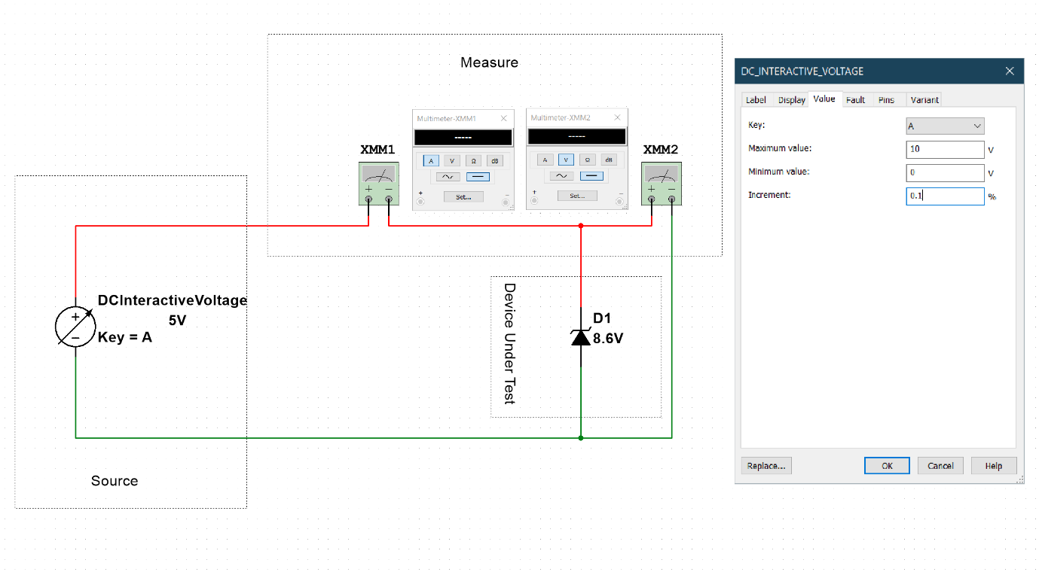
To demonstrate the Zener breakdown phenomenon and study the diode’s behaviour in both forward and reverse bias.

Diagram:

Theory:
A Zener diode is a special type of diode designed to allow current to flow in the reverse direction when the applied voltage exceeds a specified value known as the Zener breakdown voltage (Vz). Its IV characteristics include:
- Forward Bias:
  - Like a regular diode, conducts after knee voltage (~0.7V for silicon).
  - Initially, the current remains low until the voltage exceeds the knee voltage (~0.6–0.7V for Si diodes). Beyond this voltage, current rises exponentially.
- Reverse Bias:
  - Blocks current until reverse voltage reaches Vz, then conducts with a nearly constant voltage (Zener region).

Expected IV Curve:

Forward bias: Exponential rise beyond knee voltage.

Reverse bias: Nearly zero current until Vz, then sharp increase in current with minimal increase in voltage.

Materials Required:
- Zener diode (e.g., 5.1V, 1N4733A or similar).
- Digital power supply with current and voltage control.
- Series resistor (e.g., 470 Ω, 1 W) for current limiting.
- Multimeter(s) for current and voltage measurement.
- Breadboard, wires, connectors.
- Zener diode datasheet for reference (Vz, maximum ratings).

Safety Precautions:
- Current Limit: Do not exceed Zener diode’s maximum current rating in breakdown region.
- Power Dissipation: Ensure the product of Zener voltage and current (P = Vz × Iz) does not exceed the diode’s rating.
- Zero Supply: Always set supply to zero before changing connections.
- Thermal Monitoring: Pause if the diode becomes noticeably warm.

Pre-Test Setup:

Identify Terminals: Cathode (banded end), Anode (unbanded end).

Connect Circuit:

Forward Bias: Anode to positive, cathode to negative.

Reverse Bias: Cathode to positive, anode to negative, with series resistor.

Measurement:

Current measured in series, voltage across diode.

Procedure:
Forward Bias:
- Connect Zener diode in forward direction.
- Gradually increase current from 0 mA upwards (start with small steps, e.g., 1–10 mA).
- Measure and record voltage across the diode at each step.

Reverse Bias:

Reverse the diode connection.

Connect a series resistor to limit current.

Gradually increase the supply voltage in small steps (e.g., 0.5V) up to and slightly beyond the Zener voltage.

Record current and voltage across the diode at each step.

Do not exceed the maximum current or power rating.

Measurement Data Table (Simulation):
Step No. | Current (mA) |  | Voltage (V) | Comments/External Factors

IV Curve Plot (Simulation):

Measurement Data Table (Hardware):
Step No. | Current (mA) |  | Voltage (V) | Comments/External Factors

IV Curve Plot (Hardware):

Lab Evidence(s) of Hardware Testing:

Plotting the IV Curve:
- Using the recorded measurements, create a graph:
  - Current ($I$) on the y-axis.
  - Voltage ($V$) on the x-axis.
- For forward bias, observe the exponential rise beyond the knee voltage (~0.7V for silicon diodes).
- For reverse bias, the current should remain almost flat at a small leakage value, followed by a sudden increase at Zener breakdown voltage.

Observations and Analysis:
Include observations to answer:
- What is the knee voltage in forward bias? How does it relate to the expected value?
- Does the IV curve in reverse bias show negligible current as expected? What is the measured leakage current?
- Do any points indicate issues such as sudden jumps in current (possible due to range switching or thermal effects)?
- What is the overall shape of the IV curve, and how does it compare to the theoretical model?
- What is the measured Zener voltage (Vz)? How does it compare to the datasheet value?
- Is the forward knee voltage consistent with a standard diode?
- Does the reverse current increase sharply at Vz as expected?
- Are there any deviations from the ideal curve (e.g., due to resistor value, supply limitations, or heating)?

Hints:
- Relate the exponential nature of the forward curve to the diode equation: $I=I_{S}(e^{qV/kT}-1)$.
- Discuss how practical factors such as internal resistance or thermal effects may cause deviations from the ideal curve.

Troubleshooting:
- Check all connections and ensure the diode is connected with the correct polarity.
- If voltage/current readings are erratic, confirm that the power supply and meters have stable ranges and resolutions.
- Replace the diode if measurements are inconsistent or no current flows in forward bias.

5. IV Curve for a Fixed Value Resistor (100 Ω)

Objective:

To measure and plot the IV characteristics of a 100 Ω resistor.

To observe the linear relationship between current and voltage.

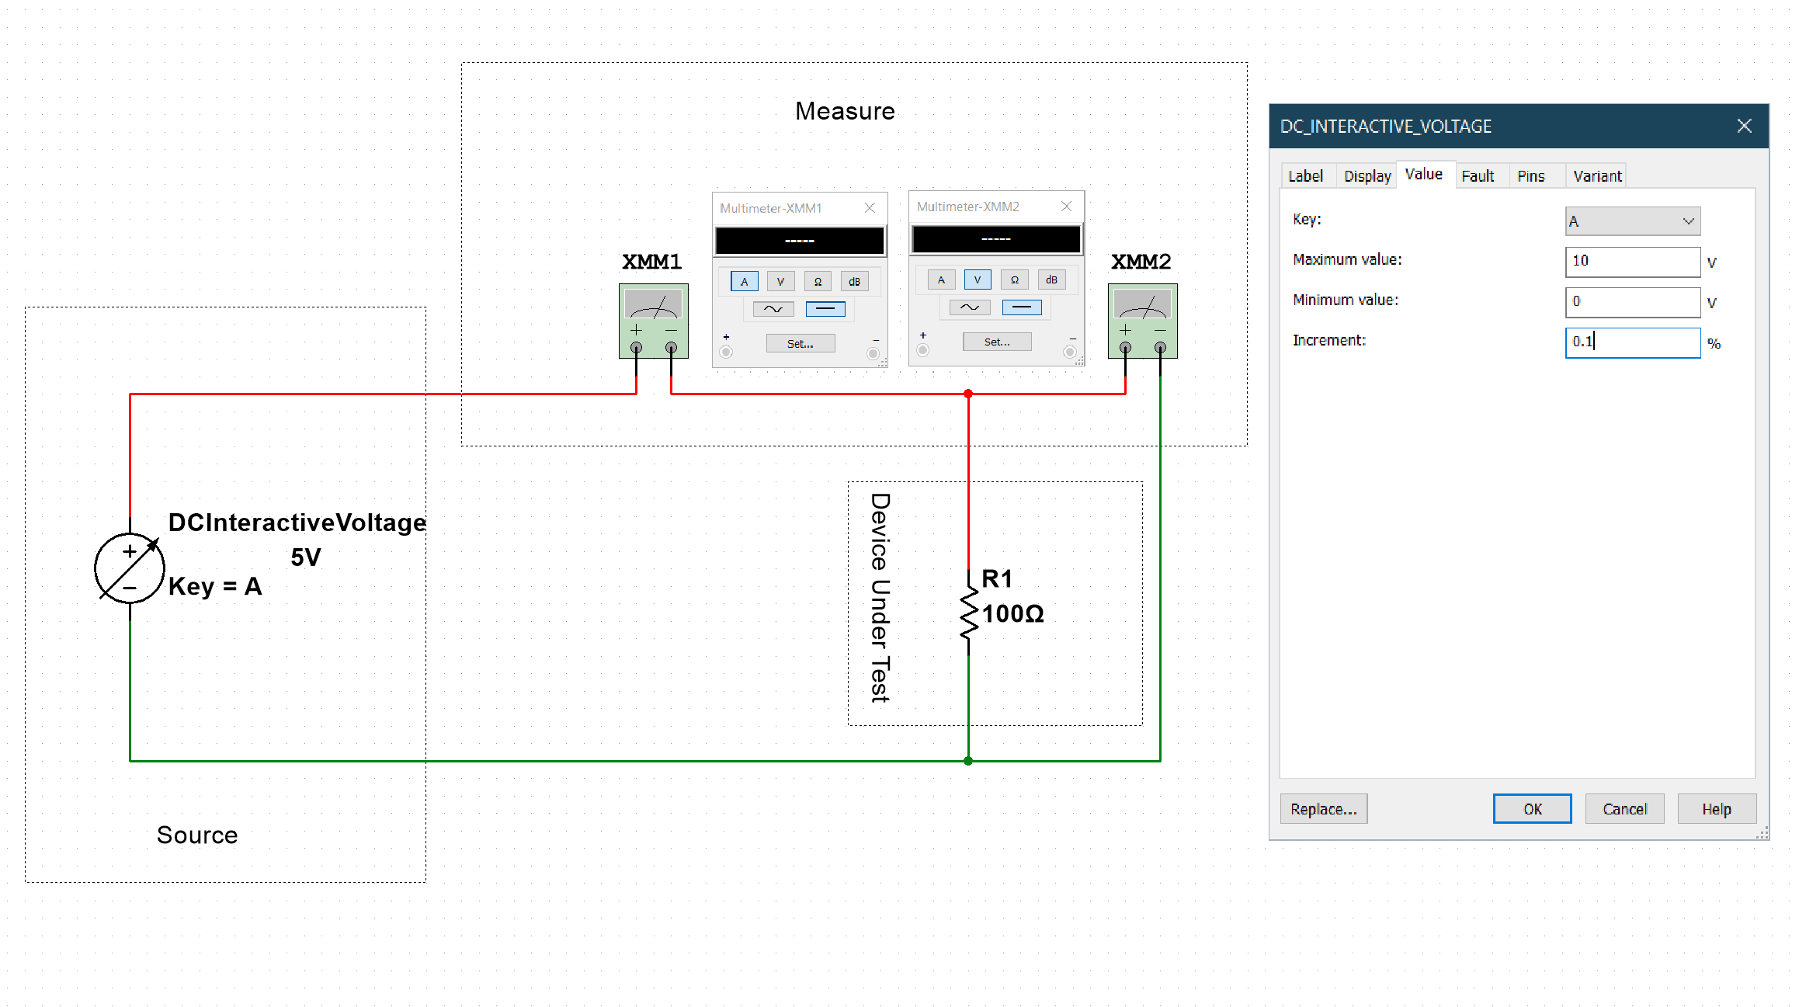
Diagram:

Theory:

A resistor is a passive electrical component that provides a precise amount of opposition to current flow. According to Ohm’s Law, the voltage across a resistor (V) is directly proportional to the current through it (I), with the proportionality constant being the resistance (R):

V = IR

This linear relationship means that the IV curve of a resistor is a straight line passing through the origin, with the slope determined by the resistance value. Resistors are used to control current, divide voltages, and protect sensitive components in circuits. The power dissipated by a resistor is given by P = V × I, and exceeding the rated power can cause overheating or damage.

Materials Required:
- 100 Ω, 1 W resistor
- Digital power supply
- Multimeter(s)
- Breadboard, wires
- Oscilloscope (XY mode, optional)
- Built-in test signal (if available)

Safety Precautions:
- Do not exceed the resistor’s power rating (P = V × I).
- Set supply to zero before connecting or switching devices.

Pre-Test Setup:

Connect the resistor in series with the power supply.

Multimeter in series for current, parallel for voltage.

If using oscilloscope XY mode, connect as per scope instructions.

Procedure:

Gradually increase current in small steps (e.g., 10–20 mA).

Record voltage across the resistor at each step.

Observe the IV curve live on oscilloscope (XY mode) if available.

Measurement Data Table (Simulation):
Step No. | Current (mA) |  | Voltage (V) | Comments/External Factors

IV Curve Plot (Simulation):

Measurement Data Table (Hardware):
Step No. | Current (mA) |  | Voltage (V) | Comments/External Factors

IV Curve Plot (Hardware):

Lab Evidence(s) of Hardware Testing:

Plotting the IV Curve:
- Plotting the IV Curve:
- Plot Current (I) on the y-axis and Voltage (V) on the x-axis.
- Expect a straight line; the slope should match the resistor value.

Observations and Analysis:
- Include observations to answer:

Is the IV curve linear as expected?

Does the slope correspond to 100 Ω?

Are there any deviations (e.g., heating, supply limits)?

Did the resistor get warm at higher currents?

Hints:
- Relate the slope to Ohm’s Law. Discuss any practical deviations due to heating or measurement error.

Troubleshooting:
- Check connections and resistance with a multimeter.
- If readings are erratic, verify meter and supply stability.
- If resistor overheats, reduce current or check power rating.

6. IV Curve for a Light Dependent Resistor (10kΩ LDR)

Objective:

To measure and plot the IV characteristics of a 10kΩ LDR under varying light conditions.

To observe how resistance changes with light intensity.

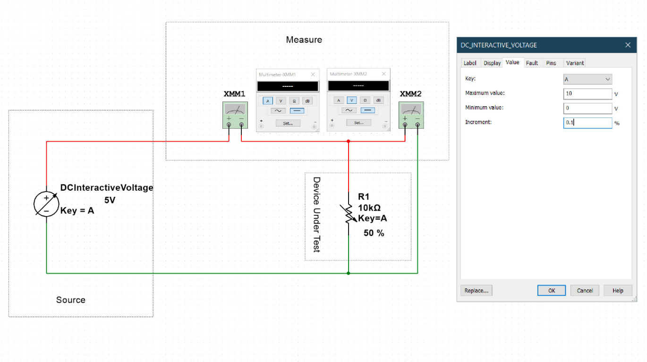
Diagram:

Theory:

An LDR is a variable resistor whose resistance decreases as the intensity of incident light increases. It is made from semiconductor materials that change conductivity based on light exposure. In darkness, the resistance is high (tens of kΩ or more), while under bright light, resistance drops significantly (hundreds of Ω or less).

The IV curve of an LDR is nonlinear and depends on the illumination level. Under constant voltage, increasing light causes more current to flow. LDRs are widely used in light-sensing applications such as automatic lighting, alarms, and brightness controls. The device’s response time and sensitivity can vary based on material and construction.

Materials Required:
- 10kΩ LDR
- Digital power supply
- Multimeter(s)
- Breadboard, wires
- Oscilloscope (XY mode)
- Built-in test signal
- Light source (lamp, torch, etc.)

Safety Precautions:
- Do not exceed LDR’s voltage/current ratings.
- Set supply to zero before connecting.

Pre-Test Setup:

Connect LDR in series with power supply.

Multimeter for current and voltage.

Oscilloscope in XY mode for live curve.

Prepare light source for varying illumination.

Procedure:

Shine light on LDR and record IV curve.

Shade LDR and record IV curve.

Observe live changes on oscilloscope (XY mode) using built-in test signal.

Measurement Data Table (Simulation):
Step No. | Current (mA) |  | Voltage (V) | Comments/External Factors

IV Curve Plot (Simulation):

Measurement Data Table (Hardware):
Step No. | Current (mA) |  | Voltage (V) | Comments/External Factors

IV Curve Plot (Hardware):

Lab Evidence(s) of Hardware Testing:

Plotting the IV Curve:
- Plotting the IV Curve:
- Plot Current (I) on the y-axis and Voltage (V) on the x-axis.
- Expect a straight line; the slope should match the resistance value.
- Observe how the curve changes with illumination.

Observations and Analysis:
- How does the IV curve change when the LDR is illuminated vs shaded?
- Is the behaviour nonlinear as expected?
- Are there sudden jumps or noise due to ambient light changes?
- Does the resistance decrease with increased light?

Hints:
- Relate curve changes to LDR physics. Discuss effects of ambient light, device heating, or contact resistance.

Troubleshooting:
- Ensure stable light conditions during measurement.
- Check connections and LDR orientation.
- If readings fluctuate, shield LDR from stray light or stabilize the light source.

7. IV Curve for a Potentiometer (5kΩ)

Objective:

To measure and plot the IV characteristics of a 5kΩ potentiometer at different knob positions.

To observe how resistance and IV curve steepness change with adjustment.

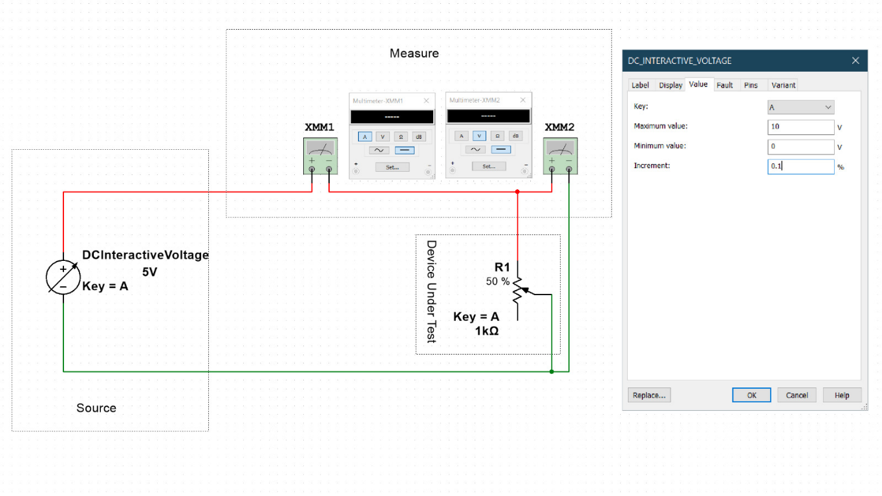
Diagram:

Theory:

A potentiometer is a three-terminal variable resistor with a sliding contact (wiper) that adjusts the resistance between the terminals. By rotating the knob, the resistance between the wiper and either end terminal changes, allowing for precise control of voltage or current in a circuit.

When used as a variable resistor (rheostat), the potentiometer’s IV curve at a fixed position is linear, similar to a standard resistor. Adjusting the knob changes the slope of the IV curve, reflecting the change in resistance. Potentiometers are commonly used for volume controls, tuning circuits, and calibration. Care must be taken not to exceed the power rating, especially at extreme positions where resistance is minimal and current can be high.

Materials Required:
- 5kΩ potentiometer
- Digital power supply
- Multimeter(s)
- Breadboard, wires
- Oscilloscope (XY mode)
- Built-in test signal.)

Safety Precautions:
- Do not exceed potentiometer’s voltage/current ratings.
- Set supply to zero before connecting.

Pre-Test Setup:

Connect potentiometer in series with power supply.

Multimeter for current and voltage.

Oscilloscope in XY mode for live curve.

Procedure:

Set potentiometer to minimum resistance, record IV curve.

Adjust knob to increase resistance, record IV curve at several positions.

Observe live changes in curve steepness on oscilloscope (XY mode) using built-in test signal.

Measurement Data Table (Simulation):
Step No. | Current (mA) |  | Voltage (V) | Comments/External Factors

IV Curve Plot (Simulation):

Measurement Data Table (Hardware):
Step No. | Current (mA) |  | Voltage (V) | Comments/External Factors

IV Curve Plot (Hardware):

Lab Evidence(s) of Hardware Testing:

Plotting the IV Curve:
- Plot Current (I) vs Voltage (V) at various knob positions.
- Observe how the slope changes as resistance is adjusted.

Observations and Analysis:
- How does the IV curve steepness change with knob position?
- Is the relationship linear at each setting?
- Are there discontinuities or erratic readings at extreme positions?
- Did the potentiometer get warm or show signs of damage?

Hints:
- Relate slope changes to resistance adjustment. Discuss risks at extreme positions and practical deviations.

Troubleshooting:
- Avoid rotating the potentiometer to extremes for prolonged periods (risk of burning).
- Check connections and ensure smooth knob movement.
- If readings are unstable, clean contacts or replace potentiometer.
- If device overheats, reduce current or check power rating.

